

ACTIVITY-BASED ASSESSMENT
SMART PARKING SYSTEM

COMPUTER SCIENCE AND ENGINEERING
Digital Design and Computer Organization
(BDDCB301)

Submitted by

- GOUTHAMI P M (1AT24CS067)
- HARSHINI D (1AT24CS072)
- INDRAJA A (1AT24CS077)
- J C MONISHA (1AT24CS078)
- K ARUNA PATIL (1AT24CS083)

Semester/Section: III Semester / CSE B

Under the Guidance of Prof. Vijayalakshmi

Department of Computer Science and Engineering

AY :2025-

TABLE OF CONTENTS

Chapter No. | Title | Page No.
1 | Abstract | 3
2 | Introduction | 4
3 | Problem Statement | 5
4 | Code | 6-7
5 | Flowchart and Block Diagram | 8
6 | Working | 9-10
7 | Applications | 11
8 | Result | 12
9 | Conclusion | 13
10 | Photos | 14

CHAPTER 1

ABSTRACT

The Smart Parking System is an automated solution developed to address the growing problem of parking management in urban areas. Traditional parking methods depend largely on human effort and visual inspection, which often leads to inefficiency and inconvenience. This project uses sensors to detect the availability of parking slots and a microcontroller to process the collected data. The real-time information is then displayed to users through a digital board or mobile application. By reducing the time spent searching for parking spaces, the system helps in saving fuel, lowering pollution levels, and improving the overall parking experience. The project highlights the role of modern technologies such as IoT and automation in building smart infrastructure.

CHAPTER 2

INTRODUCTION

In recent years, rapid urbanization and population growth have led to a massive increase in the number of vehicles on the road. As a result, parking has become one of the major challenges in cities. Drivers often face difficulty in finding vacant parking spaces, especially in crowded areas like shopping malls, hospitals, and office complexes. This leads to unnecessary traffic congestion, frustration, and wastage of valuable time and fuel.
The Smart Parking System is designed to overcome these challenges by providing a technology-driven approach to parking management. By using sensors and automated monitoring, the system ensures efficient utilization of parking spaces and enhances user convenience. This project demonstrates how smart systems can replace traditional manual methods to improve urban mobility.

CHAPTER 3

PROBLEM STATEMENT

The increasing number of vehicles has made parking a critical issue in urban and semi-urban areas. Most parking lots still operate using conventional methods where drivers search manually for empty spaces. This results in long queues, traffic congestion inside parking premises, and inefficient use of available space. Moreover, the absence of a real-time monitoring system makes it difficult for parking authorities to manage slots effectively.
The lack of proper parking guidance not only wastes time but also increases fuel consumption and air pollution. Therefore, there is a strong need for an intelligent system that can automatically monitor parking spaces, guide drivers to available slots, and maintain accurate parking records. The Smart Parking System aims to solve these issues by introducing automation and real-time data management.

CHAPTER 4

CODE
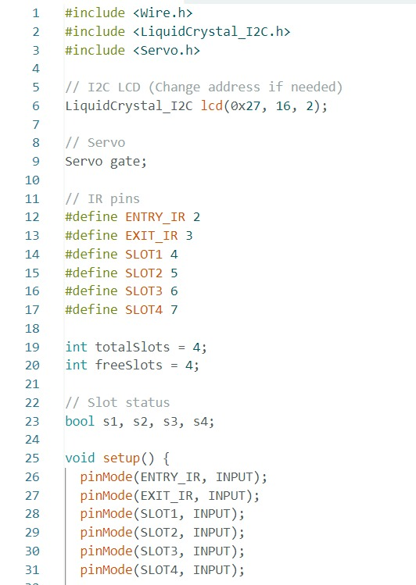
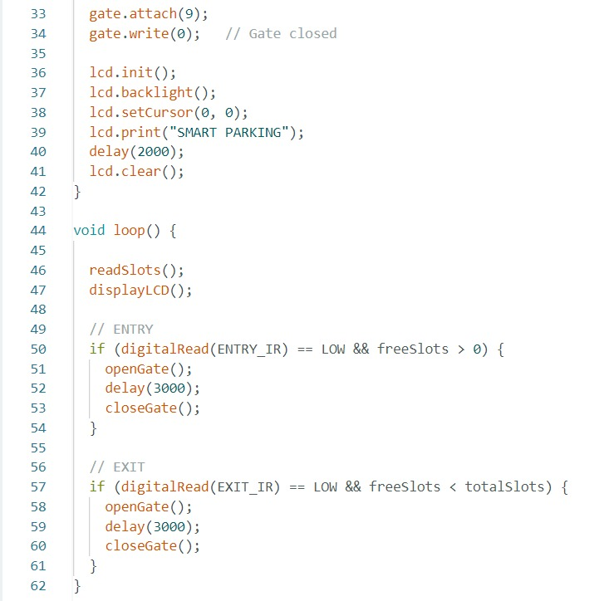

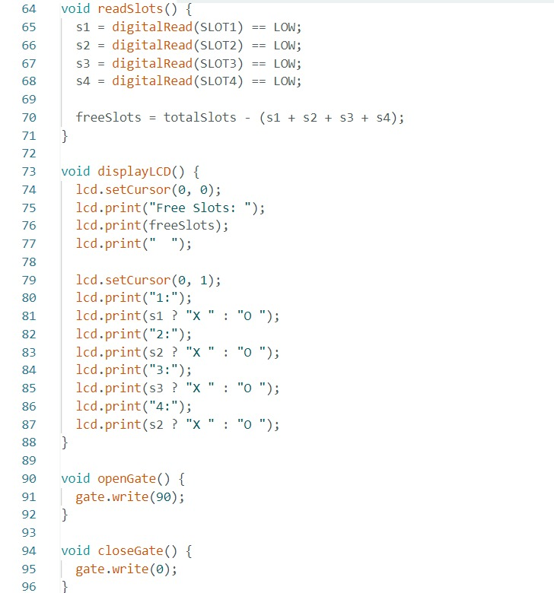

CHAPTER 5
FLOWCHART AND BLOCK DIAGRAM

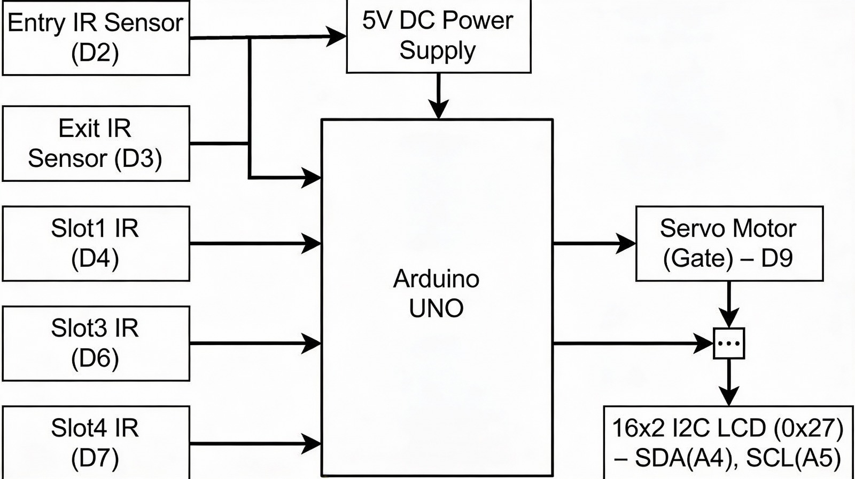

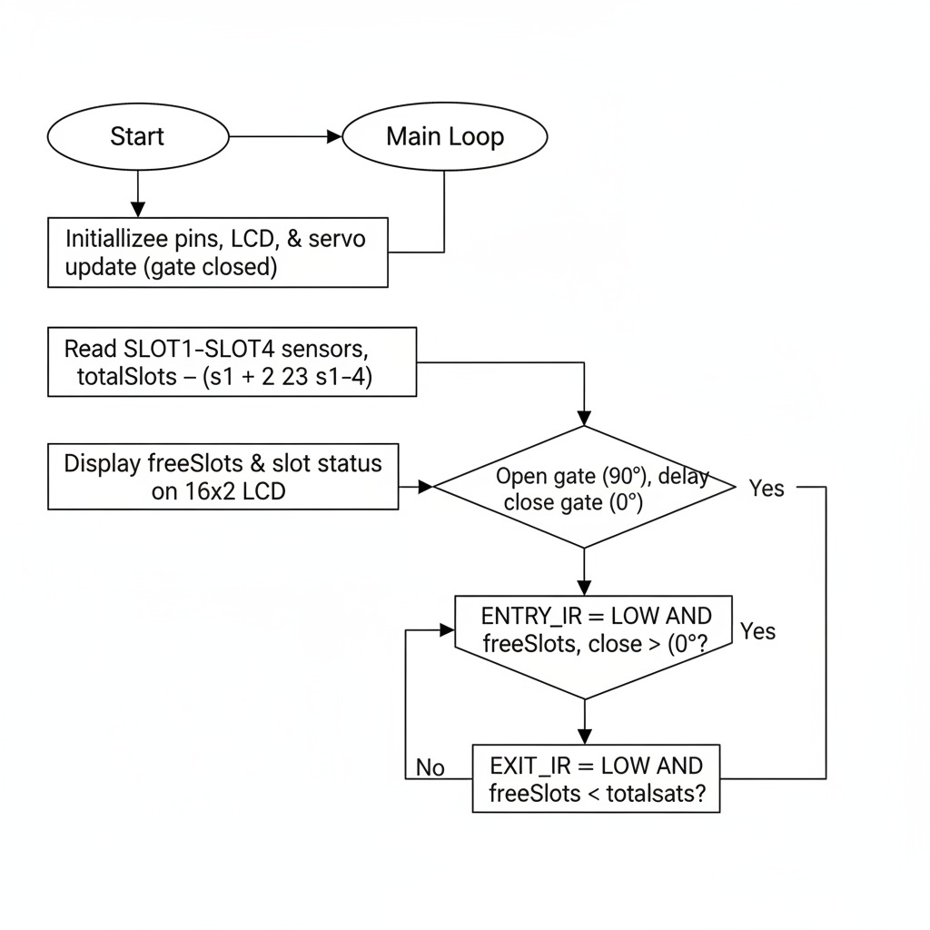

CHAPTER 6
WORKING:

This program controls a smart parking system that automatically monitors parking slot availability, displays the status on an LCD screen, and controls the entry/exit gate using a servo motor. It uses IR sensors to detect vehicles at the gate and in each parking slot.

1. System Initialization
When the system is powered ON, the setup() function runs first.
- All IR sensors (entry, exit, and slot sensors) are configured as input devices.
- The servo motor is attached to pin 9 and set to the closed position (0°).
- The LCD display is initialized and shows the message “SMART PARKING” for a few seconds.
- After this, the system is ready to monitor parking activity.
This step ensures that all hardware components start in a proper and safe condition.

2. Continuous Monitoring Process
The loop() function runs continuously and performs three main tasks repeatedly:
- Reads parking slot status
- Displays information on LCD
- Controls the entry and exit gate

3. Reading Parking Slot Status
The function readSlots() checks the condition of all four parking slots.
- Each IR sensor detects whether a vehicle is present.
- If the sensor output is LOW, the slot is considered occupied.
- If the sensor output is HIGH, the slot is free.
The system then calculates the number of free slots using this formula:
Free Slots = Total Slots – Occupied Slots
This ensures the system always knows the real-time parking availability.

4. Displaying Information on LCD
The function displayLCD() shows the parking status on the LCD screen.
- The first line displays the total number of free slots.
- The second line shows the status of individual slots:
  - O → Slot is empty
  - X → Slot is occupied.

5. Entry Gate Control
When a vehicle arrives at the entrance:
- The entry IR sensor detects the vehicle.
- If at least one slot is free, the system:
  - Opens the gate using the servo motor
  - Waits for 3 seconds
  - Closes the gate again
If no slots are available, the gate remains closed, preventing unnecessary entry and congestion.

6. Exit Gate Control
When a vehicle leaves the parking area:
- The exit IR sensor detects the vehicle.
- The system automatically:
  - Opens the gate
  - Allows the vehicle to exit
  - Closes the gate after a short delay
Once a vehicle exits, the number of free slots increases and the display is updated automatically.

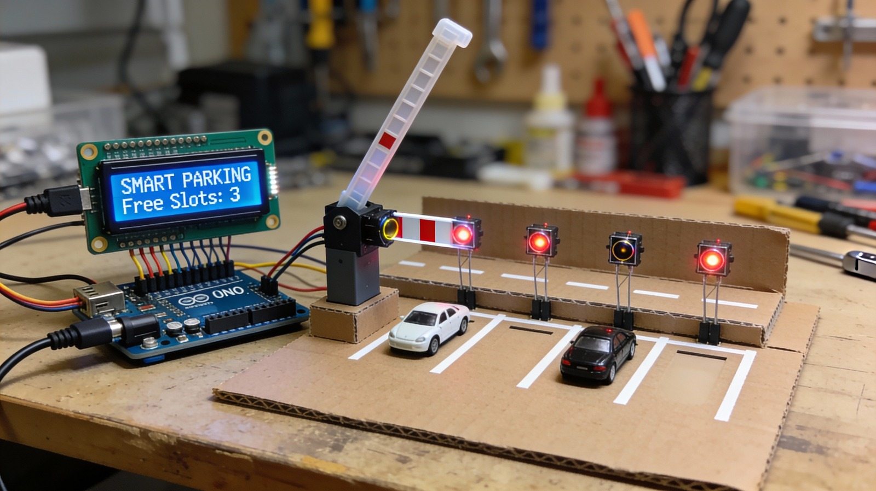

CHAPTER 7

APPLICATIONS

1. Shopping malls and multiplexes
In shopping malls, a large number of vehicles arrive every day, especially during weekends and holidays. The Smart Parking System helps customers quickly find empty parking spaces, reducing entry congestion and improving their overall shopping experience. It also helps mall authorities manage parking more efficiently.

2. Hospitals and healthcare centers
Hospitals require fast and smooth parking access, especially for emergency vehicles and visitors. The system ensures that parking spaces are clearly identified and allocated, reducing delays and stress for patients and their families.

3. Airports and railway stations
These locations handle a very high volume of vehicles daily. The Smart Parking System helps in organizing parking spaces, guiding drivers to available slots, and reducing traffic congestion in entry and exit points.

4. Educational institutions
Colleges and universities can use the system to manage parking for students, staff, and visitors. It prevents overcrowding and ensures that parking spaces are used properly without confusion.

5. Corporate offices and IT parks
In office complexes, parking space is often limited. The Smart Parking System improves space utilization and reduces the time employees spend searching for parking, helping them start their workday smoothly.

6. Residential apartments and gated communities
In housing societies, the system helps residents and visitors park without disputes or confusion. It provides better security and organized parking management.

7. Smart city projects
As cities move toward digital infrastructure, smart parking becomes an essential component. It supports sustainable development by reducing fuel consumption, pollution, and traffic congestion.

CHAPTER 8

RESULT

After successful implementation and testing, the Smart Parking System showed strong performance in managing parking operations. Each result demonstrates the effectiveness of automation in real-life scenarios.

1. Accurate detection of parking slots
The sensors reliably detected whether a parking slot was occupied or vacant. This accuracy ensured that users received correct information, preventing confusion and misguidance.

2. Real-time availability display
The system updated parking slot information instantly on the display or app. This helped drivers make quick decisions and reduced unnecessary movement inside the parking area.

3. Reduction in parking search time
Users were able to find parking spaces faster because they were guided directly to available slots. This saved time and reduced frustration, especially during peak hours.

4. Smooth automated gate operation
The entry and exit gates operated automatically based on slot availability. This minimized the need for manual control and reduced long queues at the entrance.

5. Decreased manpower requirement
Since most operations were automated, the dependency on security staff and parking attendants was reduced. This lowered operational costs and improved system reliability.

6. Better organization of parking spaces
The system ensured that parking slots were used efficiently and systematically. This reduced overcrowding in certain areas and improved overall traffic flow inside the parking facility.

CHAPTER 9

CONCLUSION

The Smart Parking System proves to be a practical and efficient solution to the modern parking challenges faced in urban environments. By integrating sensors, microcontrollers, and real-time data display, the system ensures better utilization of parking spaces and reduces unnecessary traffic congestion. This project highlights the importance of smart technologies in building sustainable and intelligent infrastructure. With further enhancements such as mobile app integration, number plate recognition, and online booking, the system can be expanded into a fully automated smart parking solution for future cities.

CHAPTER 10

PHOTOS
